1. **Introduction**

The food ordering system is a simple php based program to calculate the total of the order and display the orders. The program is designed using checkbox, radiobox and a button. It’s made simple so that the user can use it without the need of a guide or any problem.

**Screenshots**

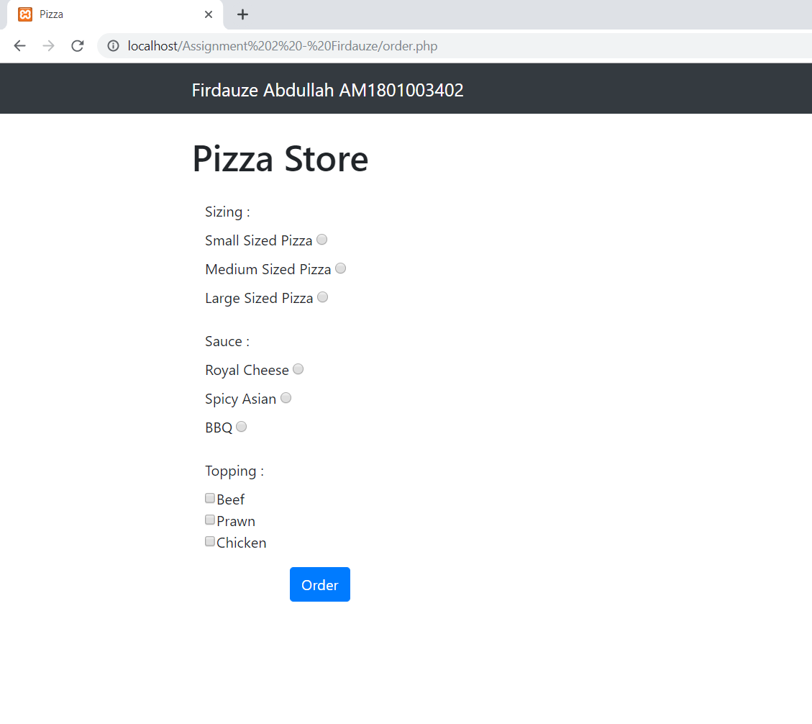

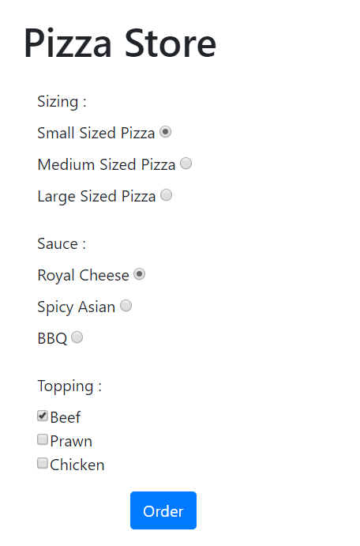

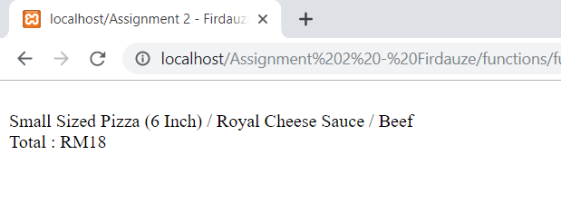

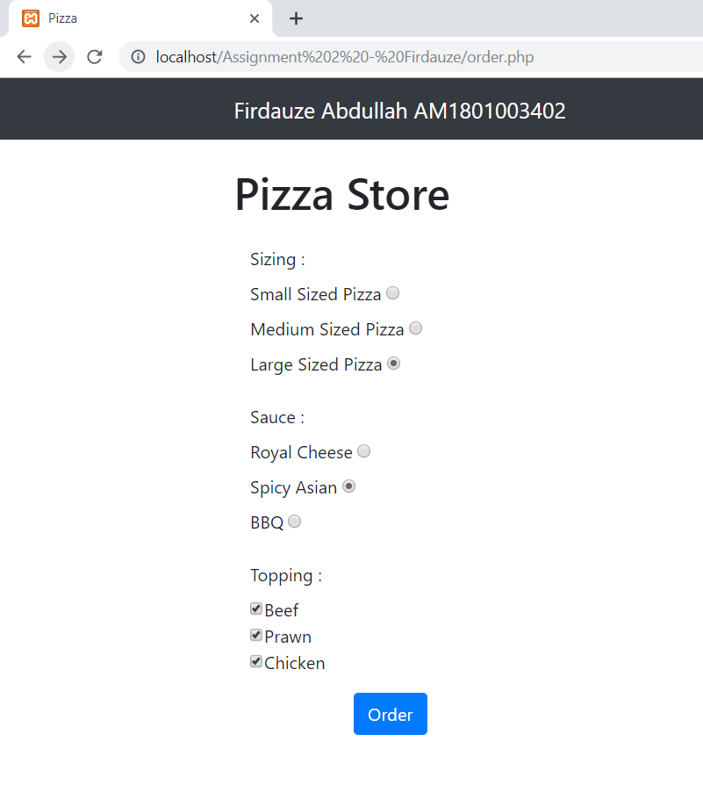

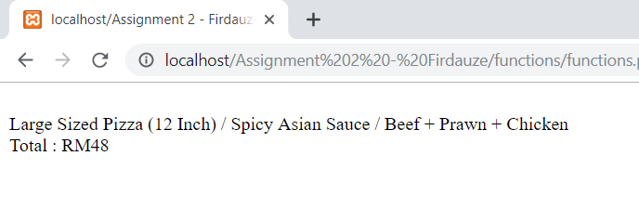

**Coding**

**Order Page**

<?php

include "include/nav.php";

?>

<!DOCTYPE html>

<html lang="en">

<head>

<meta charset="utf-8">

<meta name="viewport" content="width=device-width, initial-scale=1, shrink-to-fit=no">

<meta name="description" content="">

<meta name="author" content="">

<title>Pizza</title>

<!-- Bootstrap core CSS -->

<link href="vendor/bootstrap/css/bootstrap.min.css" rel="stylesheet">

<!-- Custom styles for this template -->

<link href="css/shop-homepage.css" rel="stylesheet">

</head>

<div class="container">

<div class="row">

<div class="col-lg-3">

<h1 class="my-4">Pizza Store</h1>

<body>

<div class="container">

<div class="row">

<div class="col-lg-9">

<form name="Order" id="OrderForm" method="POST" action="functions/functions.php">

<div class="control-group">

<label>Sizing : </label>

<div class="form-group col-xs-12 floating-label-form-group controls">

<label>Small Sized Pizza</label>

<input type="radio" name="PizzaSize" value="smallPizza"><br>

<div class="control-group">

<div class="form-group col-xs-12 floating-label-form-group controls">

<label>Medium Sized Pizza</label>

<input type="radio" name="PizzaSize" value="medPizza"><br>

<div class="control-group">

<div class="form-group col-xs-12 floating-label-form-group controls">

<label>Large Sized Pizza</label>

<input type="radio" name="PizzaSize" value="largePizza"><br>

</div>

<div class="form-group">

<label>Sauce : </label>

<div class="form-group col-xs-12 floating-label-form-group controls">

<label>Royal Cheese</label>

<input type="radio" name="Sauce" value="rc"><br>

<div class="control-group">

<div class="form-group col-xs-12 floating-label-form-group controls">

<label>Spicy Asian</label>

<input type="radio" name="Sauce" value="sa"><br>

<div class="control-group">

<div class="form-group col-xs-12 floating-label-form-group controls">

<label>BBQ</label>

<input type="radio" name="Sauce" value="bbq"><br>

</div>

<label>Topping :</label>

<div class="form-group">

<input type="checkbox" name="Topping[]" value="Beef">Beef<br>

<input type="checkbox" name="Topping[]" value="Prawn">Prawn<br>

<input type="checkbox" name="Topping[]" value="Chicken">Chicken<br>

</div>

<!-- label>Topping :</label>

<div class="form-group col-xs-12 floating-label-form-group controls">

<label>Prawn</label>

<input type="radio" name="Topping" value="PrawnTop"><br>

<div class="control-group">

<div class="form-group col-xs-12 floating-label-form-group controls">

<label>Chicken</label>

<input type="radio" name="Topping" value="ChickenTop"><br>

<div class="control-group">

<div class="form-group col-xs-12 floating-label-form-group controls">

<label>Beef</label>

<input type="radio" name="Topping" value="BeefTop"><br>

--> </div>

<div class="form-group">

<button type="submit" class="btn btn-primary float-right">Order</button>

</div>

<!-- name="opt" value="1000" -->

</form>

<!-- <div class="container">

<div class="form-group">

<button type="submit" class="btn btn-primary" name="opt" value="0" >Add</button>

</div>

</div> -->

</body>

**PHP coding (functions.php)**

<?php

$pizzaSize = $_POST['PizzaSize'];

$topping = $_POST['Topping'];

$sauceT = $_POST['Sauce'];

$sauce ="";

$total = 0;

$size = "";

switch($pizzaSize)

{

case "smallPizza":

$size = "Small Sized Pizza (6 Inch)";

$total = $total + 10.0;

for($i = 0; $i < count($topping); $i++)

{

switch($topping[$i])

{

case "Prawn":

$total = $total + 5.0;

break;

case "Chicken":

$total = $total + 5.0;

break;

case "Beef":

$total = $total + 8.0;

break;

}

}

break;

case "medPizza":

$size = "Medium Sized Pizza (9 Inch)";

$total = $total + 20.5;

for($i = 0; $i < count($topping); $i++)

{

switch($topping[$i])

{

case "Prawn":

$total = $total + 5.0;

break;

case "Chicken":

$total = $total + 5.0;

break;

case "Beef":

$total = $total + 8.0;

break;

}

}

break;

case "largePizza":

$size = "Large Sized Pizza (12 Inch)";

$total = $total + 30.0;

for($i = 0; $i < count($topping); $i++)

{

switch($topping[$i])

{

case "Prawn":

$total = $total + 5.0;

break;

case "Chicken":

$total = $total + 5.0;

break;

case "Beef":

$total = $total + 8.0;

break;

}

}

break;

}

switch ($sauceT)

{

case "sa":

$sauce = "Spicy Asian Sauce";

break;

case "bbq":

$sauce = "BBQ Sauce";

break;

case "rc":

$sauce = "Royal Cheese Sauce";

break;

}

echo '<br>';

echo $size . " / " . $sauce ." / " . implode(" + ",$topping);

echo '<br>';

echo "Total : RM" . $total;